UNIT 1. ELECTRONICS IN THE HOME
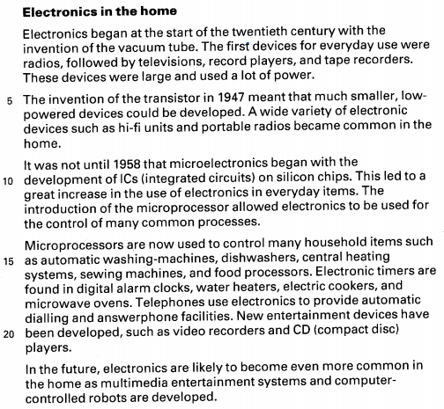

Task 4. Fill in the gaps in this table with the help of the text.
Date | Invention | Applications in the home
early 20th century | Vacuum tube | Radios, television, record players, and tape recorders.
1947 | transistor | Hi – fi units and portable radios
1958 | Microelectronics,  Microprocessor  Electronic timers | - ICs (integrated  circuits) on silicon chips.  - Automatic washing machines, dishwashers, central heating systems, sewing machines, and food processors.  - Digital alarm clocks, water heaters, electric cookers, and microwave ovens.
future | Electronics | - multimedia entertainment systems, and computer – controlled robots

Task 5. Use the space below to make a list of ways in which you think electronics may be used in the home in the future.
- Control the electronic devices in the home using gestures or speech.
- Wifi waves used to charge electronic devices in the family.
Writing about the radio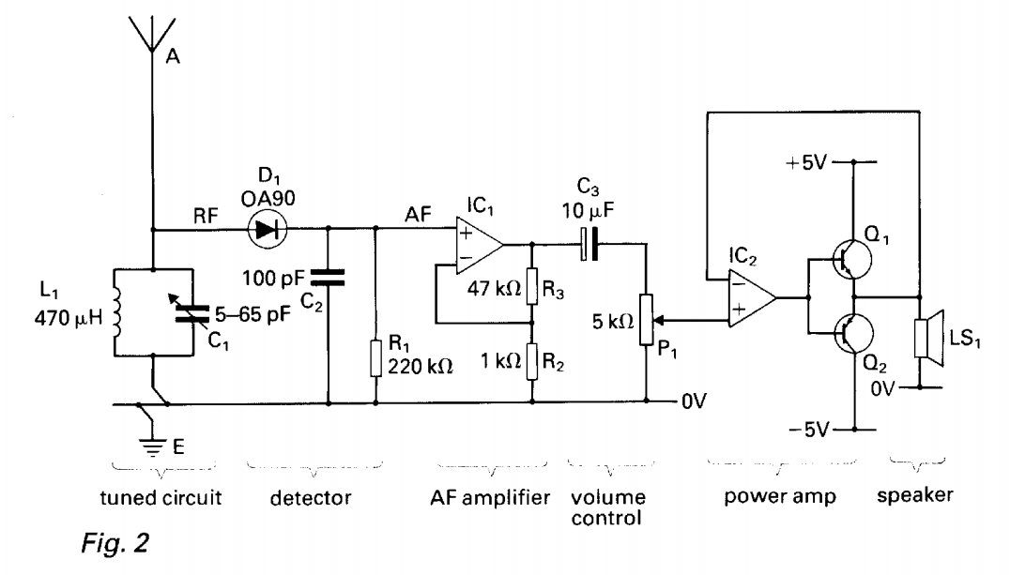
The radio consists of a tuned circuit, a detector, an AF amplifier, a volume control, a power amp, and a speaker.
The tuned circuit is connected to the dectector. The circuit is composed of a four hundred and seventy microhenries inductor which is connected in parallel with a variable capacitor. The tuner can be varied between five and sixty-five variable resistor. The aerials is connected to the top end of the tuner. It is also connected to the positive terminal of the diode in the detector. The bottom end of the tuner is connected to earth via zero voltage supply rail.
The detector is connected to the AF amplifier. The detector is composed of a OA90 diode, a hundred picofarad capacitor and a two hundred and twenty kilohm resistor are connected in series. The AF amplifier is composed of an integerated circuit (${IC}_{1}$) , a forty – seven kilohm resistor and a kilohm resistor. That two resistors are connected to the cathode of the integerated circuit and the positive terminal of the integerated circuit is connected to the output of the detector.
The volume control consists of a ten – microfarad electrolytic capacitor connected in series with a five – kilohm potentiometer (pot). The positive terminal of the capacitor is connected to the output of the AF amplifier and the wiper of the pot is connected to the power amp. The third terminal of the pot is connected to the zero voltage supply rail, which is earthed.
The power amp is composed of an integerated circuit (${IC}_{2}$), a transistors PNP which is connected in parallel with a transistors NPN. The negative terminal of the integerated circuit (${IC}_{2}$) is connected to the positive terminal of the speaker and the negative terminal of the speaker is connected to the zero voltage supply rail, which is earthed. The C terminal of the transistors PNP is connected to the five voltage and the E terminal of the transistors NPN is connected to the negative five voltage.

